Message from the President

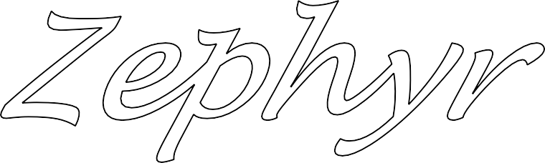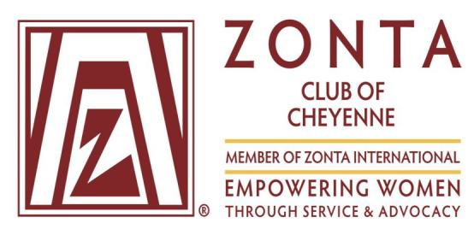

**Outstanding Women**

New Members and New Officers

Page 2-3 Women of Merit Page 3-4

**Zonta Says NO**

**What????**

Page 6

**Art Contest Winners**

Page 6

**Announcements**

Get these on your calendar! Page 9-11

**Bonding in Boots**

Page 11

**District 12 Conference In Denver!!!**

Page 12

***What’s Inside***

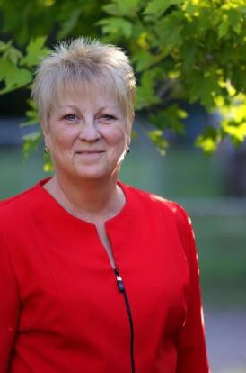As your in-

*July’s Meeting*

*will be*

*a fun and festive picnic.*

coming President, THANK

YOU, for your trust in me to

lead this club for the next year. I am excited to start working with our membership to move our mission forward. I want to say a big Thank You to Belinda Sawyer and Pam Pafford for all their hard work this past year and look forward to working with them in the coming year.

2026 is our 70th Anniversary and I am looking forward to celebrating our achievements and to see how far we have come. I am hoping you all will



come to the meeting with ideas and energy to get the celebration started.

At our June meeting we will be asking you to sign up for a committee, or subcommittee, as you all are aware that is how we get things done. Team work is the center of our achievements.

Mark your calendars for the 2nd Thursday of each month for our regular Members meeting. Take time out of your busy schedule and join the team.

Let’s have a record year in membership, advocacy and service.

***Betty***

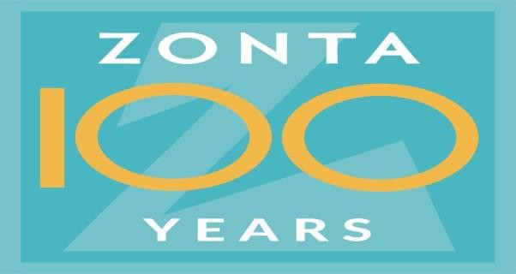

#### A group of women posing for a photo AI-generated content may be incorrect.A person standing in a room AI-generated content may be incorrect.Our May meeting welcomed new members and new officers……

Zonta Young Women in Leadership Award, Loriana Walter

Past Presidents

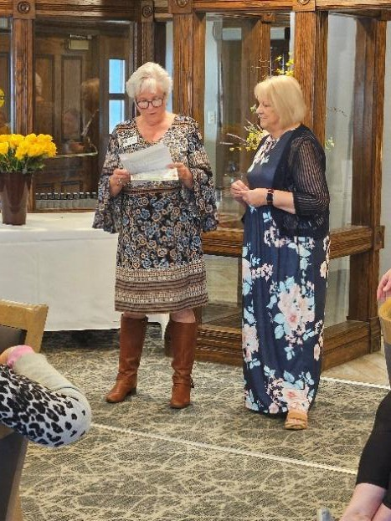Ten of our fourteen new members were initiated and welcomed at our May meeting by Kathy Cathcart, and the club. (not in order) Hannah Poole, Debi Eldridge, Katelyn Jaure, April Carter, Katheryn Carter, Angelina Young, Vicky Martinez, Katie Weber, Shaina Newton, Char Madden, Barbara Spier, Susan Keeler. Not able to attend: Olivia Salazar, Carla Nelson Peterson.

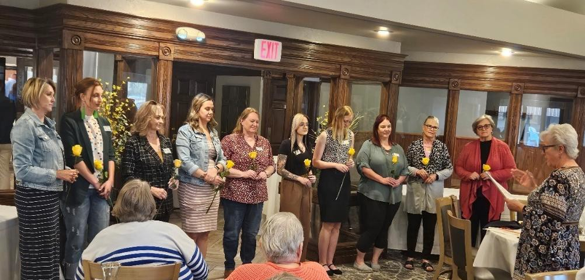

Our 2025 Officers were installed. President-Betty Abernethy, Vice President-Jennica Fournier, Director- Kim Bowie, Director-Samantha Fales, Secretary- Michelle Huff, Director- Kathy Orr, Director- Denise Parrish and Past President- Belinda Sawyer. Kathy Cathcart inducted Betty Abernethy as our 2025 President during the ceremony.

*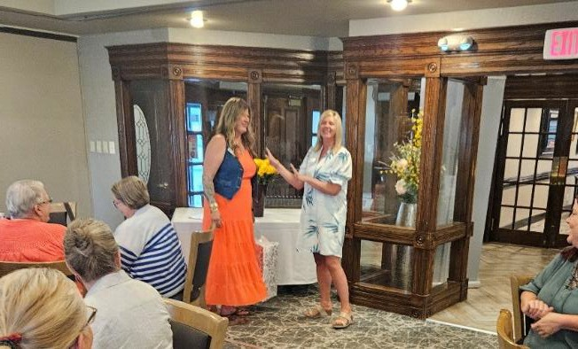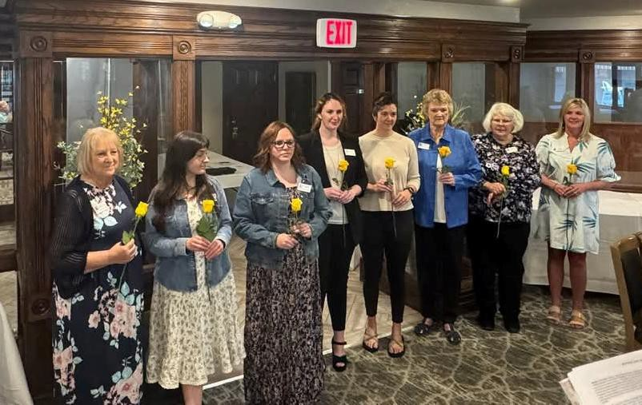The evening was full of celebrations……*

Zontian of the Year, Pam Pafford

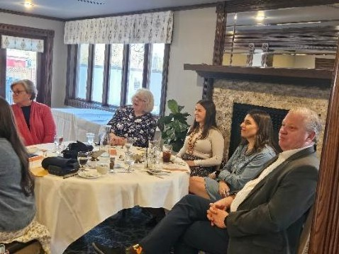 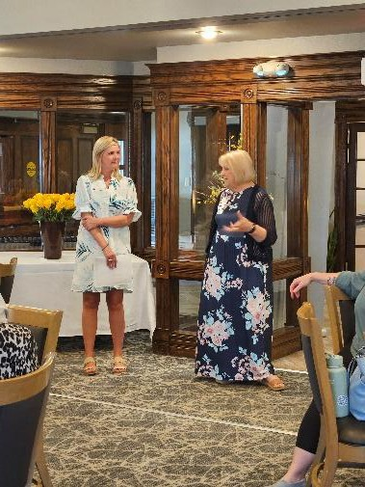

*2025 President Betty Abernethy shared her plans: for the Cheyenne club to grow in membership, service and involvement on the local level, the district level, and the international level. She encouraged each member to have an “elevator speech” ready and wear their Zonta pin. Also, bring a dollar, just in case.*

*By Kathy Orr*

 2024 President Belinda Sawyer

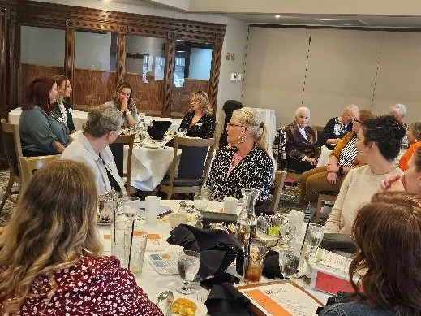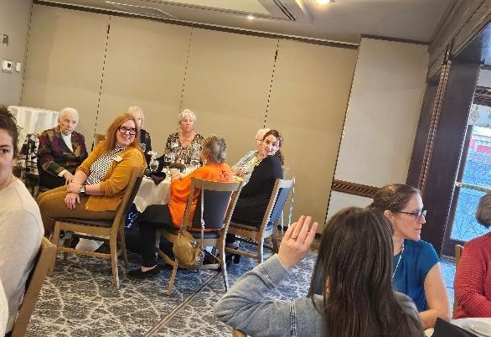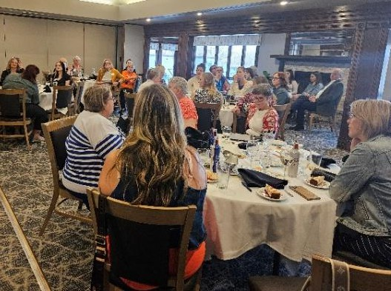

## Zonta Young Women in Leadership

*weightlifting, graduation team, and academics. In*

*We presented our Zonta Young Women in Leadership Award to Loriana Walter. At 18, Loriana would make a great Zontian because it is apparent she ALREADY struggles to say no when*

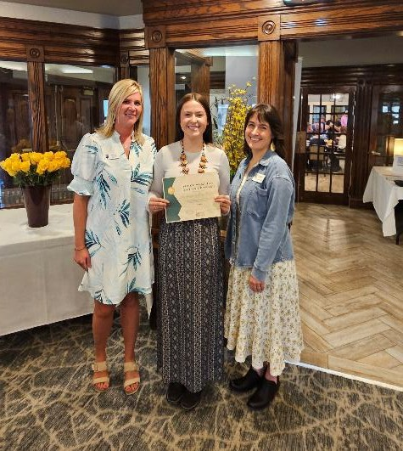

*asked to serve. Loriana is the senior class president at East high school where she is in the top 10% of her class academically, she has participated in Girl’s State, National Honors Society, and has won Congressional Awards including bronze, silver and gold medals. She has lettered in cheer, dance, choir, student council,*

*cheer, she earned her place as a Wyoming Allstate Cheerleader. Many of our former Girl Scouts will be happy to know that she has earned Girl Scouts silver and bronze awards and traveled internationally with the organization. Loriana somehow finds time for employment and works for Boots on the Ground Productions and at Ulta. In addition, she participates as a recreational leader for the City of Cheyenne and is also a Youth Development Professional for the Boys and Girls Club. You also may have seen her in the summer, riding as a CFD Dandy. Her letters of reference were exceptional and noted her great potential as a leader and that she was kind, warm and genuine. She plans to attend North Dakota State University and major in agricultural communications. She already plans to jump right into college organizations by joining Sigma Alpha, an agricultural sorority. She understands the challenges she will face entering a male dominated field, but we are positive that she will be a leader for all and pave the way for more exceptional women like herself. By Jennica Fournier*

***Zontians shine and demonstrate their merit…***

Kim Bowie was recently crowned as America’s Civic Miss Wyoming.

MS Kim Bowie 2025! Kim continues to support programs like this to help support girls and ladies develop into strong women.

One of our new members, Kathryn Carter graduated from the University of Wyoming Saturday May 17th, 2025 with her Bachelor’s in Psychology.

Congratulations and many wishes for a great future!!!

## Eight Members Attend Safe House Luncheon

Safe House hosted its big fundraiser of the year on May 13th at the CFD Convention Center. Dasa Robertson, Katie Wright, Samantha Fales, Jody Gostas, Betty Abernethy, Michelle Aldrich, Kathy Orr and Michelle Huff attended, enjoying the event and supporting a great community agency focused on helping women, men and families at a time of crisis.

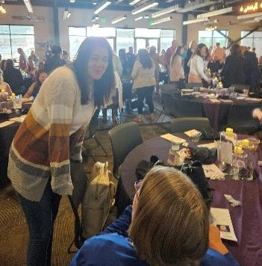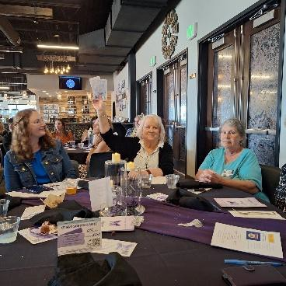

Members in New Positions

* Cassandra Stith is chairing the Zonta Women in Business Leader Award program.
* Denise Parrish is chairing Zonta’s participation with the community Food Drive, August 23rd, 9:00

– 3:00.

* Kim Bowie is helping with our club’s social media.
* Hannah Poole is maintaining the CheyenneZonta.org website, with Carolyn D’Ambro.
* Kathy Orr is editor of our newsletter *The Zephyr*. (Cheyenne Zephyr News@ gmail.com)
* Jill Randall is co-chairing Membership/Communication committee with Betty Abernethy.
* Ann Erdmann offered to be host of a book study on “First Political Order” by Valerie Hudson.
* Michelle Huff is coordinator of our Hope Bag project.
  + (Your name here) has joined a new committee!!~ Good Job everyone!!

***Advocacy and Service: Current Project and Date***

#### Coasters and Posters

1. *June 12th (June Club Meeting- Sign up for Distribution)*
2. *July 3rd (Goal for Poster/ Coaster printing completion)*
3. *July 8th 2:30-5:00 Grace UMC Hall (Party to put materials together for distribution)*
4. *July 10th (July Club Meeting- Sign up for Distribution)*
5. *July 14th-18th (Distribute coasters and posters to the bars)*
6. *July 18th-19th (Distribute posters at CFD Park)*

Cheyenne Frontier Days offer our members a variety of hands-on activities that promote awareness about Domestic Violence and Human Trafficking and offer help. When our city triples its size with visitors, it becomes a venue for these unwanted issues and more.

*We definitely make Zonta’s presence known to our community and guests with these coasters and posters.*

**Volunteers are needed** with this year’s Coasters and Posters projects. (See poster attached)

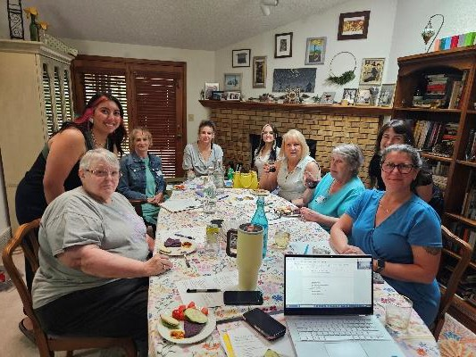At our June and July’s meetings we will invite you to sign up for any (or all) of our jobs, assignments and activities.

Watch for the sign-up sheets that will be coming your

way, or call Jennica or Kathy 0.

Join Us!!!

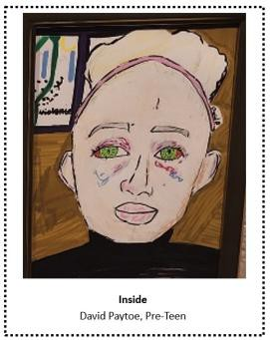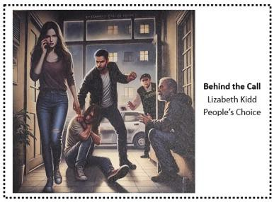

**AND THE WINNER IS….**

This year, twelve different artists submitted a total of fifteen art pieces to be included in our annual Zonta Art Contest. The theme of this year’s contest was *Bystanders Can Be Heros*. We had one pre-teen entry, six entries by artists in their teens, and eight entries by adults. The three art categories, based on the age of the artists, were judged by three members of the Cheyenne art community. The winners were David Paytoe (pre- teen), Aurora Eguizabal (teen) and Allison Wagg (adult). The judges were asked to consider representation of the theme, creativity, and artistic presentation. There was also a People’s Choice Award presented to Lizabeth Kidd, which was determined by the votes of the viewing public. Each of the winners received a $150 prize.

Interestingly, the 65 People’s Choice votes that were cast were spread across 13 of the 15 art entries. The art hung in the lobby of the Cheyenne Civic Center for most of the month of May. Staff of the Civic Center shared that quite a few people came by to specifically view the art from the Zonta contest. Furthermore, there were a significant number of comments made by attendees of the Zonta May 2nd Art Reception about the high caliber of the art and the powerful messages the various pieces portrayed. Discussion will occur in the near future as to whether the Art Contest should happen next year or if it should be replaced with a different activity. By Denise Parrish

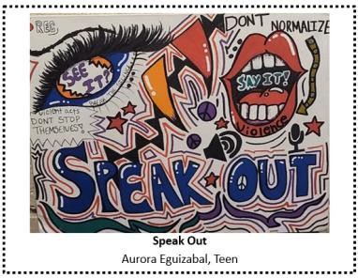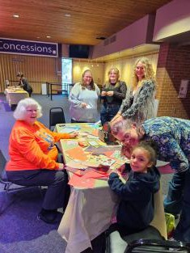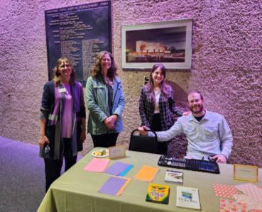

# Zonta Says NO Pledge

Have you seen the Zonta Says NO Pledge on the Zonta

International website? If not, it is available below. Or, check it out at

<https://zontasaysno.com/pledge/> and consider sharing it on your social media.

**I WILL:**

* **Say NO** to violence against women and girls.
* **Say NO** to violence in any form, whether physical, psychological or via the Internet.
* **Support** or host a program on gender-based violence.

**CHECK IT OUT!**

Zonta Says NOW has an on-line Art Gallery. It has works by 45 different Zonta artists representing every continent.

**Find it at:** [https://zontasaysnowvirtualartgal](https://zontasaysnowvirtualartgallery.org/) [lery.org/](https://zontasaysnowvirtualartgallery.org/)

**SAVE THE DATE!**

**CHEYENNE COMMUNITY FOOD DRIVE**

**SATURDAY, AUGUST 23RD**

**9 a.m. – 3 p.m.**

**Beneficiaries:**

Veterans’ Rock LCCC Food Pantry

**Collection Points:**

Albertson’s (Yellowstone Rd.) Safeway

King Soopers

Sign-up Sheets for One Hour Shifts will be available in late July.

**PLEASE VOLUNTEER!**

**Sponsored by Rotary and Rotoract Clubs, Kiwanis, Lions Clubs, Zonta**

* **Learn more about** gender-based violence found at [the Zonta Says NO](https://zontasayno.com/) website.
* **Reflect on what I learned** during the 16 Days and speak up via social media and with family and friends throughout the year.
* **Invite the men and boys** in my family and community to take the pledge, speak up and take action to prevent gender-based violence.

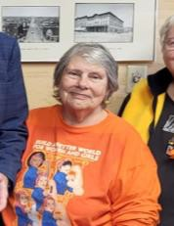

“I have nothing to send for the Zephyr, except that I will be thinking of Zonta when I'm in France from 5/25 - 6/1 0. Au revoir!”

***Bring back something delicious to share, Jody***!!!

# May Meeting’s Minutes

**ZONTA CLUB OF CHEYENNE**

**MEMBERSHIP MEETING MINUTES, MAY 2025**

**6:00pm @ Cheyenne Country Club**

**Meeting was called to order at 6:03pm by President Belinda Sawyer Celebrations/Announcements**

**Ice Breake**r – Kathy Orr. We wrote down 2-3 words that describe us in the style of weather reporting

##### Dasa – Treasurer’s report

* + Membership dues were highlighted. Membership fees will be paid out on June 1st

##### Jennica – Advocacy

* + Art contest went well. Approximately 30 attendees
  + Hope Bag Inventory is complete
* We have lots of items. Should we consider allocating those items to other causes?
  + Coasters and Posters. Explained what that was to new members and reminded members to volunteer during frontier days
  + May 13 – Advocacy meeting hosted by Jennica
  + Young Women in Leadership Award was presented to Lorianna, who was accompanied by her parents

##### Betty – Membership and Communication

* + Cancel Out reception went well
  + 10 new members
  + Betty has set a goal of 100 members in the club
  + New member orientation will be in June/July
  + Next meeting is May 27th @ Betty’s

##### Pam Pafford – Zontian of the Year!!

* + - Cancel out committee is looking to pass off to new members to take over planning and coordination
* Wine grab
* Raffle
* Sponsors/tickets
* Silent auction
* New ideas
* $9000 was given to Safehouse of Cheyenne to update their security systems
* Next Cancel Out event is March 6, 2026

@ CFD

##### Kathy Cathcart - New Board was approved

* + - Installation of new President, Vice President, and officers

##### Laura and Karen are doing the Audit Betty Abernethy – President

* + - Looking for more participation and more members
    - Challenged the group to wear Zonta badge in public and come up with an elevator speech to explain what Zonta is and what is our mission

##### Ann Erdman

* + - Offered to host a book discussion on the reading of First Political Order by Valerie Hudson
    - Women, Peace & Security Act

##### Meeting was adjourned at 7:10pm Submitted by Michelle Huff, Secretary

***Announcements***



*Looking for volunteers to serve on the Application Review Committee.

Stay Tuned

June Club Meeting ***Speaker: Bridget Masters Past Governor of ZI***

June 12th @ The Office Meeting starts at 6:00 pm

Advocacy & Service Committee

Next Meeting- June 17th at 5:30- Place TBA

Current Project and Dates- Coasters and Posters

See page 5 for more details

Our next **Zunco** event

is planned for June 6th, 5:30 at **Applebees**.($15)

Fast moving fun, food, and cash prizes…

Visit with District 12 Celebrities

Membership & Communications Committee Meeting

June 3rd @ 5:30 at Betty’s Home

814 E. Jefferson Rd.

*Come help us plan for the summer!*

***The Aviator and The Showman*** Amelia Earhart, George Putnam, and the Marriage that Made an American Icon

*“A new book, written by Laurie Gwen Shapiro, has dug deep into the archives and emerged with an exhilarating tale of the adventurous life of Amelia Earhart and her remarkable relationship that helped to forge her legend.” Google Books*



**Zonta Foundation :**

Ann Erdmann, President Linda Bogart, Vice President

Melissa Martin, Treasurer Denise Parrish, Secretary Vickie Ingerle, Director

***Upcoming Meetings & Events:***

**Zonta Club Meeting**

June12 @5:15 (if you ordered dinner) Meeting at 6:00 pm—The Office

**Advocacy & Service Committee Meeting**

June 17th tentatively Place TBA

**Zonta Board Meeting**

June 5th @ 5:30 pm

Betty Abernethy’s Home-814 E. Jefferson Rd.

**Membership/Communications Committee Meeting**

June 3rd @ 5:30

At Betty’s: 814 E. Jefferson. Rd.

**Zappy Hour**

Watch your inbox

for emails from [ZontaFun@gmail.com!](mailto:ZontaFun@gmail.com)

[**www.cheyennezonta.org**](http://www.cheyennezonta.org/)

|  |  |
| --- | --- |
| ***Lynn Storey- Huylar*** | ***6/09*** |
| ***Shaina Newton*** | ***6/20*** |
| ***Kathy Orr*** | ***6/26*** |

**2025 Club Officers And Board**

**President:** Betty Abernethy [bettyabernethy@gmail.com](mailto:bettyabernethy@gmail.com) **Vice President:** Jennica Fournier [jennicafournier@gmail.com](mailto:jennicafournier@gmail.com) **Secretary:** Michelle Huff [mnre130@yahoo.com](mailto:mnre130@yahoo.com) **Treasurer:** Tracy Myers [tracym1996@gmail.com](mailto:tracym1996@gmail.com)

**Immediate Past Pres:** Belinda Sawyer

**Board of Directors:** Kathy Orr Denise Parrish Kim Bowie Samantha Fales

**Nominating Committee**

Ann Erdmann Melissa Martin (Vacancy)

**Committee Chairs** Advocacy/Service: Jennica Fournier Finance: Kathy Cathcart

Membership/Communication: Jill Randall and

Betty Abernethy

Zonta International Foundation for Women Ambassador: Mary Walker

Club Historian: Linda Bogart

**ZONTA CLUB OF CHEYENNE PRESENTS THE lst ANNUAL**



**A HIKE WITH ZONTIANS, FRIENDS, AND FAMILY JUNE 14, 2025-9:00 AM**

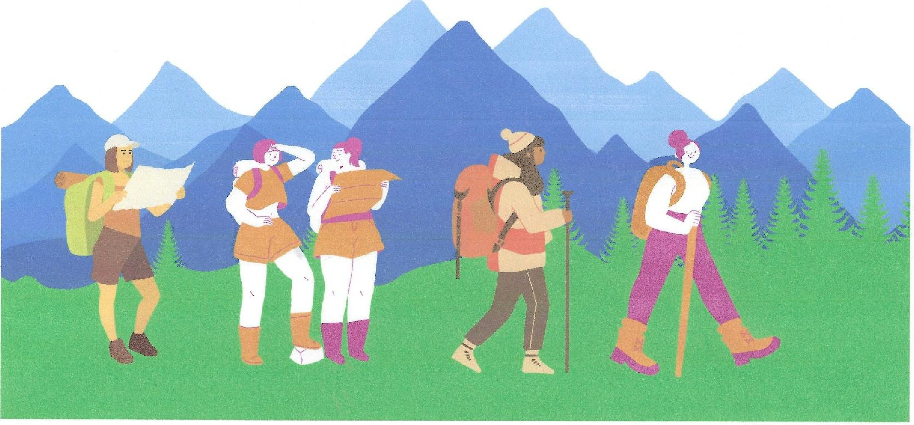

**TURTLE ROCK TRAIL INFORMATION AND MAPS**

**WHEN** June 14, 2025, 9:00 AM

**WHERE** Vedauwoo Box canyon Gazebo, Hiking Turtle Rock Trail

* ·�. *.:. -:*

.� • �- - -·� ... :: ,.,

**WHO**

### WHAT TO EXPECT

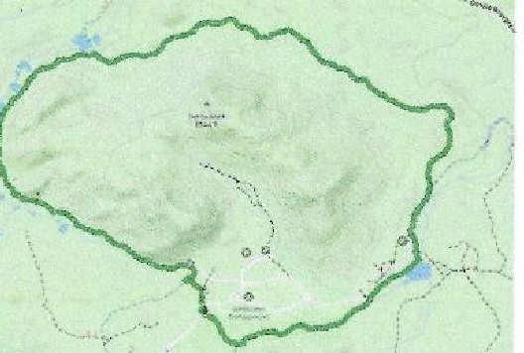

'

,

Area 2 Zontians and anyone they want to bring along! Hiking not required!

We will meet at the gazebo at 9 AM

and start hiking by 9:15 AM. Non-hikers please enjoy the Gazebo, eat snacks and play yard games. For seasoned hikers this 3-mile trail can take 1-2 hours. Since we are with a big group,

2.9 mi 311 ft 1 h 9 m c;::>

U1-n;tt1 Ekiveaon gan &;tim?.':ed time **loop**

�'-- HTTPS:/fwww.ALLTRAILS.COM(TR

'I' All/us/wvoM!NG(TURTLE•ROCK•

**LOOP•TRAIL_**

�� **HTTPS:/IMAPS.APP,GOO,Ol/4QLB**

**WSFWYN4EPWJA7**

**RSVP HERE:**

�'-- **HTTPS:/[DQCS.GOOGLE.COM/FORMS**

### WHAT TO

**BRING**

of all skill levels, expect to take -3

hours to hike the trail. **Please RSVP!**

Please bring at least 1-2 liters of water tor each member of your party, ample snacks, appropriate shoes and clothing for June in Wyoming, and $5 to pay the entrance fee. No pets.

'I' **/p{E/lfAIPQLSCKXZGVPSK• ALFTJRJPYIHMEIUOXOOUROPKll97R**

**AZK83LMG/VIEWl'Q..B.M..t USP•HEADER**

**CONTACT** Jennica Fournier

307-630-0380 (call or text)

jennicafo urnier@g ma ii.com

*"There is a golden chain of loue that ties us all together*



**LDEN**

DIS R CT 12

*It unites us in one spirit and heart,*

*joined as sister and brother*

*Across the land. the sky, and sea*

*There is a golden chain by which we're bound.''*

District 12 Conference

**Sept19-20-21,2025**

**Denuer Marriott West**

**In Golden, Colorado**



**"Stay Golden" Symbolism**

**Hope and Positivity:** The idea of staying optimistic even during tough times.

**lndividuality:** Encouraging authenticity and staying true to oneself.

**A** single yellow rose has **Strength and Resilience:** Gold as a been a ZONTA Symbol for metal is unyielding and enduring.

ouer 35 years.

The ZONTA rose http:/ /Zontadistrict12.org

�

**ZONTA**

INTERNATIONAL

**DISTRICT 12** BUILDABETTER WORLD FOR WOMENANDGIRLS

symbolizes joy, friendship

& appreciation.

Debbie Sundberg, '24-'26 0-12 Gouernor Questions? Email: [dsunnyone11@gmail.com](mailto:dsunnyone11@gmail.com)